Patrick Butler  
Patrick Butler has studied and played guitar with icons of four styles of music: Funk, Rock, Jazz, and Celtic music. He has formerly studied with guitarists Harry Leahey, Uli Roth, and Roland Prince.

He was taught Celtic and Bluegrass by his father as a child then learned rock and funk while studying the comprehensive method of Harry Leahey

Harry Leahey was a student of Johnny Smith, the Master of Chordal Theory, and Dennis Sandole, the legendary Philadelphia based guitar and music theory teacher whose most famous students included John Coltrane, Pat Martino, James Moody, Benny Golson, Micheal Brecker and others.

Butler still has all his Leahey lesson books that contain this priceless musical knowledge.

Upon graduating high school he played with jazz legends James Spaulding and Richie Cole but fell into the more lucrative R&B market doing gigs and studio work at most of the famous studios in the Tri State area including Joe Robinsons All Platinum Studios. After touring stints with the Fifties icons, The Drifters, Butler was invited to join The Fatback Band, a Polydor Records funk unit from Queens, New York. The first record he recorded with Fatback, Brite Lites/Big City, went gold. The next release had the first rap single recorded by a major label “King Tim the Third”.

Butler spent the next several years touring extensively with Fatback. He recorded two more records with the band, including XII, which contains the track King Tim III, the first rap track ever released on a major label.

Moving to Los Angeles, Butler concentrated on original rock music with his funk rock power trio Unstoppable. The boys had many adventures and met all the LA based musicians famous and obscure. Butler recorded with Stephen Perkins’ acid jazz jam band, Banyan which included Flea from the Red Hot Chili Peppers. He also appears on Mike Watt’s Sony release: Ball Hog or Tugboat on a track featuring Henry Rollins.

Into the new millennium Butler went back to his roots and led and toured with the Celtic rock band Superkeltic; the band was mentioned as one of the top Celtic rock bands in America by Winnie Czulinski in her history of Celtic music, Drone On! In 2005 He converted his Celtic Band to back up Country Western singers in military base tours which culminated in a week at Guantanamo Bay Marine base for the 2006 Fourth of July celebration. This gig was filmed and made into a Texas Public TV documentary.

In 2007, tired of constant gigging he decided to stop being a professional musician and got his BA and teaching credential in Social Studies at Cal State Long Beach and spent the next decade in California public schools; he has written two books about his experience in teaching and is seeking a publisher.

During this time, he still sought to study music and record. Butler released eight jazz influenced projects, five of which made the Jazz top 100 charts. During this Butler also studied with the classical rock master Uli Roth attending all five Los Angeles Sky Academy weeklong sessions. Butler then took the complete music composition course with Pail Navidad at Orange County Community College

Butler currently plays with the Long Beach, CA-based acid jazz band MajicBulletTheory and Billy Meza’s Praise Band every Sunday at Calvary Cross Chapel in Cerritos.

Butlers recordings are available on his website [butlerjazz.com.](https://www.butlerjazz.com)

Contact info; 323 365 9952 [patrickbutler@yahoo.com](mailto:patrickbutler@yahoo.com)

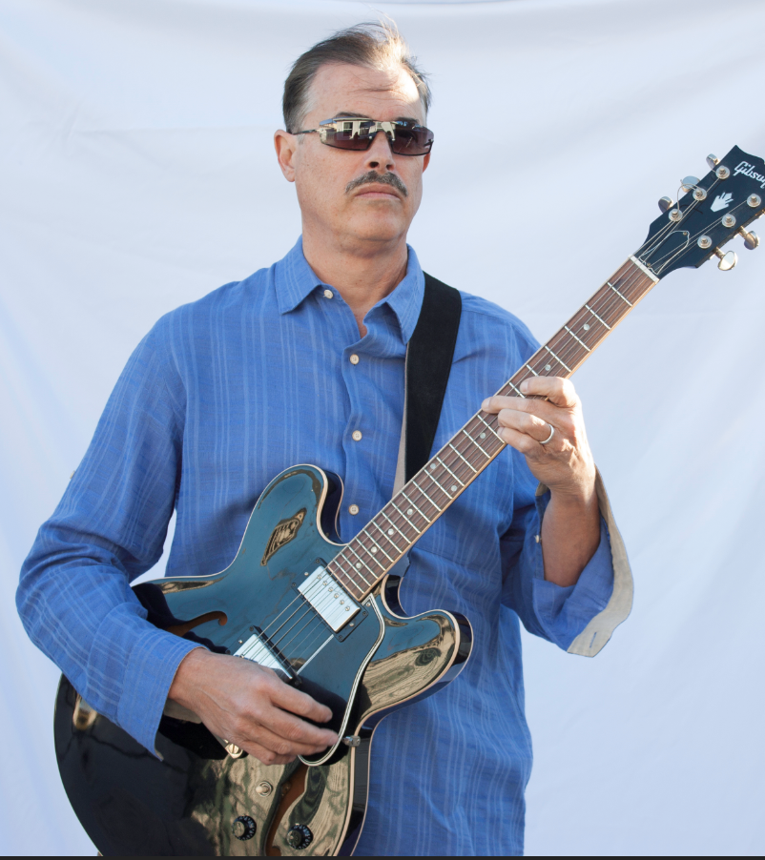

Patrick Butler on YouTube

Jazz

<https://www.youtube.com/channel/UCALK2QIpsX6z_90hIe5qqDA>

Celtic

<https://www.youtube.com/channel/UCYOGM9yJvM4gjnZqbN_n7gg/featured>